**Computer architecture (including hardware components, operating systems, memory, storage, etc.)**

1.

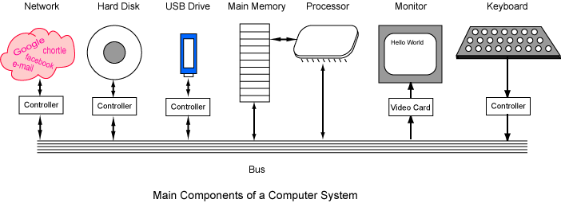**these are the components of the hardware**

**Operating systems-**

This is software that allows the computer to manage the computer’s hardware and also software resources. This provides the service for the actual computer programs, and also the operating system is a very main part of essential components of the system. Applications most of the time require an operating system to be able to function.



Many different tablets use different types of operating systems for example a Microsoft windows tablet would use windows and an Apple product would use the apple operating system. On the raspberry pi you could either run Linux or Microsoft windows.

**Memory-**

the computer contains many different types of memory’s that could be found in the computer you can have, Register memory, the main memory (RAM) and also the disk memory, you could even put external devices into your computer which will allow you to have extra memory on your computer.

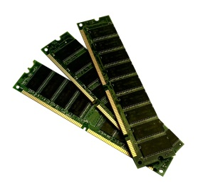

On the tablet the memory is inside of the tablet and you will not need to buy things like hard drive to put stuff into the memory of the tablet. The tablet also has certain about of memory on it.

**Storage-**

This is the place where the data is put into an electromagnetic or even an optical form, it is stored there and then accessed by the computers processor. There are two general usages for this.

**Monitor-**

This will display what is happening in the computer and show it on the screen, without the monitor it would be close to impossible to navigate on the computer.

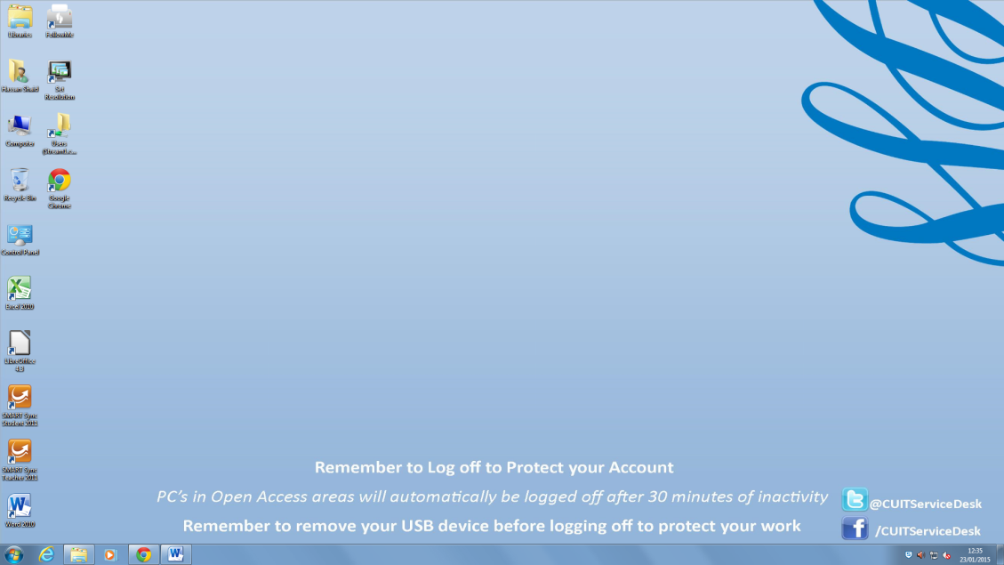

You can also connect your tablet and Raspberry pi to a monitor then you will be able to see what are you doing on them. If you connected a monitor to a tablet you would be able to see what is happening on the tablet via the tablet screen and also the monitor. Without a monitor you would not be able to see what happens on the Raspberry pi.

**Keyboard-**

The keyboard is used to enter letters, symbols and also numbers, the keyboard can allow you to enter texts into documents or also search things on the web.

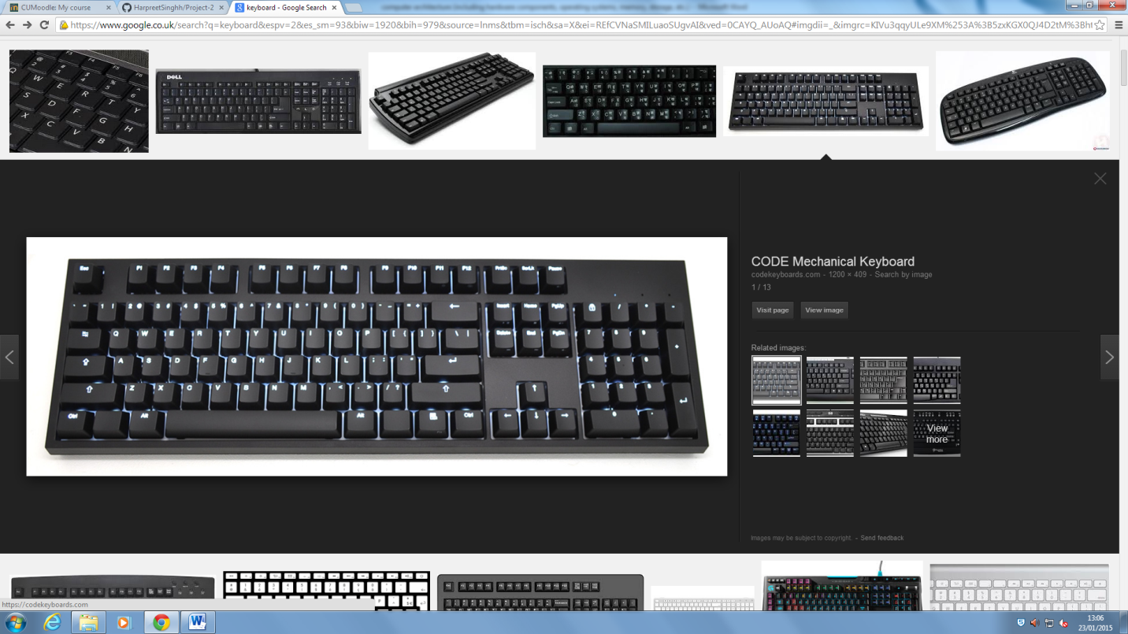

**Mouse-**

This allows you to click on things you see on the monitor, you can right click on files/folders this will allow you to gain access to them. You can also left click and this will give you options.

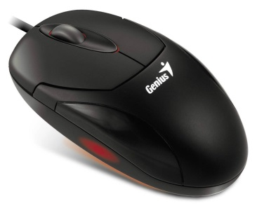

**References**

1. Image was from <http://chortle.ccsu.edu/java5/Notes/chap01/ch01_4.html>

**2.https://www.doc.ic.ac.uk/~wl/teachlocal/arch1/notes/notes2.pdf**

**3.** **http://searchstorage.techtarget.com/definition/storage**

Tuesday, 20 January 2015

[https://www.google.co.uk/search?q=Operating+systems&espv=2&es_sm=93&source=lnms&tbm=isch&sa=X&ei=vzzCVImpLdbiat-PgKAL&ved=0CAgQ_AUoAQ&biw=1920&bih=979#imgdii=_&imgrc=YcmGFQWPnj19bM%253A%3By9lk9GeceWaw1M%3Bhttp%253A%252F%252Fimg1.wikia.nocookie.net%252F__cb20120225014143%252Frtechsupport%252Fimages%252F1%252F18%252FTechnology-operating-systems.gif%3Bhttp%253A%252F%252Frtechsupport.wikia.com%252Fwiki%252FFile%253ATechnology-operating-systems.gif%3B304%3B210](https://www.google.co.uk/search?q=Operating+systems&espv=2&es_sm=93&source=lnms&tbm=isch&sa=X&ei=vzzCVImpLdbiat-PgKAL&ved=0CAgQ_AUoAQ&biw=1920&bih=979#imgdii=_&imgrc=YcmGFQWPnj19bM%253A%3By9lk9GeceWaw1M%3Bhttp%253A%252F%252Fimg1.wikia.nocookie.net%252F__cb20120225014143%252Frtechsupport%252Fimages%252F1%252F18%252FTechnology-operating-systems.gif%3Bhttp%253A%252F%252Frtechsupport.wikia.com%252Fwiki%252F)

[https://www.google.co.uk/search?q=Operating+systems&espv=2&es_sm=93&source=lnms&tbm=isch&sa=X&ei=vzzCVImpLdbiat-PgKAL&ved=0CAgQ_AUoAQ&biw=1920&bih=979#tbm=isch&q=Memory+in+computer&imgdii=_&imgrc=ddyW7yveqdBgPM%253A%3BMrSb53ZdeP2m8M%3Bhttp%253A%252F%252Fwww.210geeks.com%252Fwp-content%252Fuploads%252F2013%252F04%252Fddr1-desktop.jpg%3Bhttp%253A%252F%252Fwww.210geeks.com%252Fproduct%252F1024mb-ddr1-266-desktop-memory-upgrade%252F%3B925%3B875](https://www.google.co.uk/search?q=Operating+systems&espv=2&es_sm=93&source=lnms&tbm=isch&sa=X&ei=vzzCVImpLdbiat-PgKAL&ved=0CAgQ_AUoAQ&biw=1920&bih=979#tbm=isch&q=Memory+in+computer&imgdii=_&imgrc=ddyW7yveqdBgPM%253A%3BMrSb53ZdeP2m8M%3Bhttp%253A%252F%252Fwww.210geeks.com%252Fwp-content%252Fuploads%252F2013%252F04%252Fddr1-desktop.jpg%3Bhttp%253A%252F%252Fwww.210geeks.com%252Fproduct%252F1024mb-ddr1-266-d)

<https://www.google.co.uk/search?q=keyboard&espv=2&es_sm=93&biw=1920&bih=979&source=lnms&tbm=isch&sa=X&ei=REfCVNaSMILuaoSUgvAI&ved=0CAYQ_AUoAQ#imgdii=_&imgrc=KIVu3qqyULe9XM%253A%3B5zxKGX0QJ4D2tM%3Bhttps%253A%252F%252Fcodekeyboards.com%252Fgalleria%252F9.jpg%3Bhttps%253A%252F%252Fcodekeyboards.com%252F%3B1200%3B409>

<https://www.google.co.uk/search?q=mouse&biw=1920&bih=979&source=lnms&tbm=isch&sa=X&ei=LUjCVKGtApDUaubMgtAC&ved=0CAYQ_AUoAQ#imgdii=_&imgrc=q3XguNOoKhSzcM%253A%3Bd0PCVAuWIm2d7M%3Bhttp%253A%252F%252Fprevenblog.com%252Fwp-content%252Fuploads%252Fmouse.jpg%3Bhttp%253A%252F%252Fprevenblog.com%252Fen%252Fmay-mouse-die%252F%3B1200%3B972>